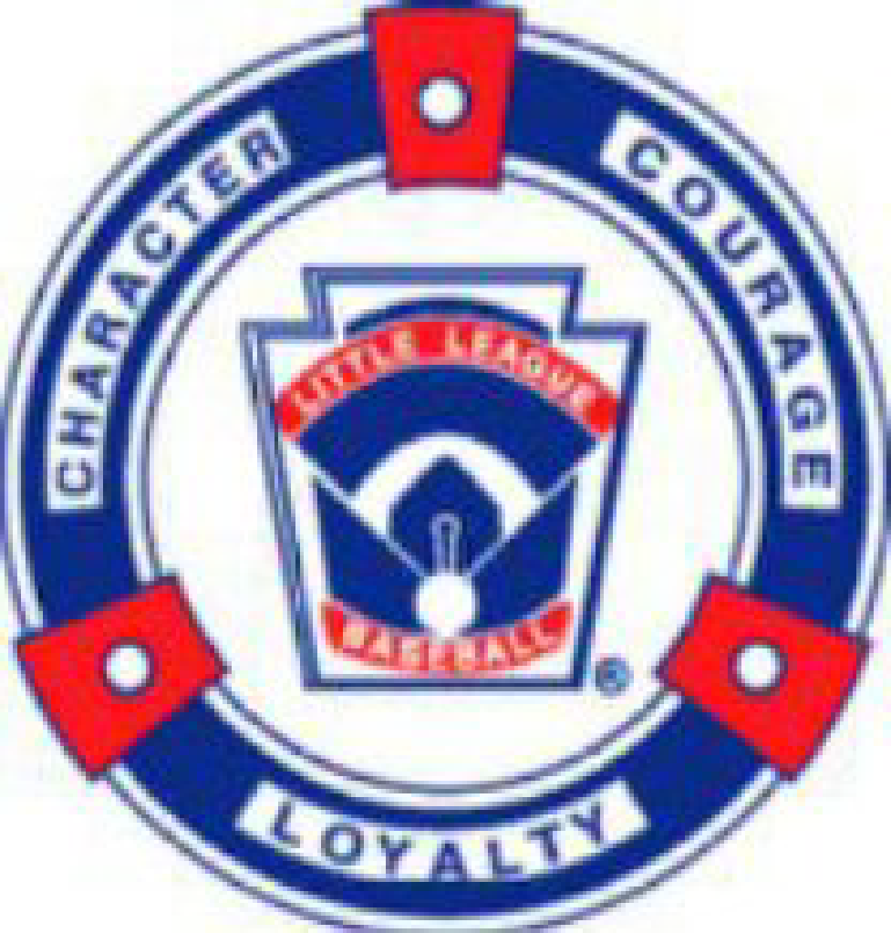

High Plains Little League (HPLL)
03/10/2025 Board Meeting Minutes

Holtz House, Falcon, CO

Attendees: Ashley Carpenter, Kevin Carpenter, Jared Holtz, April Standerfer-Holtz,
Kristina Johnson, TJ Hartley, Doug Ziegler, Becky Weese, John Hawes.
Via Phone: Brett Reed, Jackie Reed

03.10.1: Call to Order 6:09 PM
03.10.2: Meeting Minutes Sent via Email for approval for 2/17/25 - 8 responses for majority approval and posted to website.

03.10.3: Treasurer update:
- Becky Weese: Accounting status update
  - Quick books online - updating transactions. Through Oct 2024 is posted.
  - Working on coding properly.
  - Looking to get the last 2 years filed asap, preferably by April for raffle purposes.
- Audit Committee Review Notes
  - Requests: Cash box spreadsheets, check images, refund tracking through blue sombrero, Venmo reports
- Current account status: ENT and Farmers
  - Balance ENT $126,131.25
  - Balance Farmers $6,083
- Working Budget: No updates needed this month to working budget
03.10.4: Email finalize - John Hawes - Hawesome Tech
- Final Set up and file sharing, etc.- be able to share files
- April is the site admin; John will get us email address with John’s company support email if we need to get unlocked or reset;
- We can move documents from google drive to SharePoint, by uploading.
- John will get instructions on how to transfer emails from google to new email accounts. Doug has John’s number if we run into issues.
- Doug would like standardize signatures.
- Doug can set up a phone number with voicemail if we would like a number for people to call at any. Point.
- With the new email address:
  - If you delete something it’s gone forever after 30 days.
  - John can set up everyone’s signature with logo.
  - Distribution list can be set up for the board.
03.10.5: Registration update/evals, draft, coach’s clinic follow up:
- Final Numbers for registration: 479 Athletes up from 458 last s
  - Minors only division was down a team
  - There was a huge turn over with people moving away, April texted 100 people and asking if coming back and so many had moved.
- Notes/feedback from Evals, draft and coach’s clinic - Areas to improve? Overall discussion.
  - Player Evaluations
    - April said evals went awesome, smoother splitting groups and having parents wait until the kids were set up to come in and watch. Kids could get from station to station better, great feedback from parents.
    - Doug said for Softball hitting at evals they had a hard time seeing both sides to see who is hitting and we need to make it clearer both bays are evaluations. Ashley had the same feedback that she notices as well.
    - Ashley said she can do better to schedule evaluators that there was to much hopping around and want to reduce conflicts.
    - Doug said for it would be helpful if players line up number in order instead of random to make it easier. Jared said we tried with minor’s bb and it got jumbled.
    - TJ asked how eval sheets were.
      - Feedback was they had to re-write of categories had to be done because missing header on page two. League evals maybe don’t need the entire sheet just the category you’re evaluating. Hard to evaluate attitude.
    - Kev said for softball we need pitching set based on division; they were hitting good because the pitching was the same from minors all the way up to juniors; Ashley felt softball was cheated because of that.
      - Look into pitching machines use for softball to sue for hitting next year.
  - Coaches Clinic Feedback and Suggestions for next year.
    - Learning experience because we covered more material than in previous years
    - For next year, T-ball rookies time can be shortened 30-40 minutes.
      - TJ said good to keep it an hour so they can get gear while they wait for the second part of the session to start. This will keep Jeff from having so many coaches all at once.
    - Get cory Engler’s wife to come, she is a Red Cross CPR trainer. Offer for those interested to stay after the coach’s clinic to get certify. If it’s not free they pay for it but maybe HPLL provides lunch and we get a sponsor to cover lunch.
    - Jared would like at the next coach’s clinic, each board member to speak during introductions. April said each person should have a slide next year can be really quick doesn’t need much detail.
  - Absences from evaluations, there were 7 who didn’t make it, 5 with medical issues, 2 did not communicate and no show.
    - The 2 unexcused are not all start eligible.
    - April motions to excuse the 5 with medical issues. Ashely second, all in favor and none opposed.
  - Draft Feedback
    - Brett, draft feedback majors coaches felt the way we did it with coaches’ kids the teams were fairer this year. Felt teams more even and no team that will be a powerhouse. TJ said same for juniors.
    - Jared says it’s not a perfect system and he hopes coaches don’t ask kids to mess with the eval process messing up the draft fairness process. Brett said we know the kids so we can flag if we see something off with a kid’s number if they go from top ten top the bottom the following year. Brett didn’t feel any major’s coaches would have their kids sand bag next year.
      - Doug suggested next a quick review of numbers to make sure nothing looks off. Board can get an SOP in place if something weird does happen.
    - Ashely thinks as softball teams grow; she sees the benefits of following the same draft process BB used.
- Hats/Jersey Order Update: practice jerseys for softball to save money over hats/visors that they won’t use. This saved us because sb logos were costing more save $6 per unit. Practice shirts they are white with pink baseball seam print, pink HPLL logo, breast cancer ribbon and one sleeve has team name and mascot.
  - Last of hats should ship to us this week, all uniforms resto athletic.
    - Cost in 2024 $19621.60,
    - Cost in 2025 $7939.43.
- Cancellation policy update:
  - Current: 100% refund prior to player drafting/50% during first 2 weeks of regular season practice/NO Refund after first 2 weeks of regular season practice.
  - Proposed updates: 100% refund if requested prior to tryouts minus $x cancellation fee/No refunds after tryouts.
- April proposed change, charge a cancellation fee, board to vote on fee.
  - Kev proposed cancellation fee of 25% of reg fee.
- Kevin motion to approve new rules with the 25% cancellation fee. TJ second, all in favor no one opposed.
  - Brett says we should call it processing fee instead of cancellation fee.
- Volunteer Status for Coaches, help at practice, etc.
  - Sent out 20 text Sunday, 11 more to go out for T-ball and rookies. If coaches don’t do it their entire team can’t practice.
03.10.6: Facilities for 2025:
- PLC Approved for usage for Softball only, no baseball can be played at PLC.
- D-Bast use for 4 x 1hr slots for Minors, Majors, Juniors BB
  - Bobbi got all scheduled. Finalized this week.
- Porta Potty’s for 2025 season - Discuss quotes and Vote
  - 2 quotes we will need 5 units
    - JP portable restroom $150 a month with once-a-week service 750 a month.
    - 3-4 months 2250 and 3000 No issues with him last year he was responsive to issues.
    - Bigfoot portables who has 3 athletes in our league- $1627 total for the season for the 3-4 months. With once-a-week servicing. He did not say the price was a discount due to his kids just said that was the cost
    - 2024 we believe was $150 a week.
  - There is no contract, Jackie thinks we stick with what we know because we had no issues, Doug and Krista think we should try to save money and support local. And we are not under contract and can switch but give expectations to new company with cleanliness and responsive to them blowing over or having issues.
    - April motion to approve Bigfoot Portables, Krista second, all in favor, no opposed to try bigfoot portables.
- Doug- PLC wants to know if we can do improvements out there. D49 will prep it. Doug said extremely soft dirt that can cause issues. Dugouts feel like step down and bleachers are horrible. Doug would like to see if shade can be made, will need to bring pop ups, parents will need chairs if bleachers cannot be made nicer. We will see what d49 does and go from there.
- All fields will need assessment once we get them.
- Jackie said if pop ups are used at PLC they have to be careful with the wind. They will need to be secured to a fence. Jackie said pool noodles on strings to make them stand out. Reeds have two that can be used if needed.
- FMS needs fencing issues will need to be addressed so balls don’t go through backstop.
03.10.7: Equipment:
- All equipment handed out to teams at Coaches Clinic
  - All teams received equipment. Last of the Softball bats ordered were picked up from Scheels. A few coaches got the wrong balls but we have worked through that. Wed jeff will start getting field boxes set up. We may need more construction boxes, possibly two. TJ found new boxes for $1400 each.
- Will begin field set up this week.
- Jared waiting to hear from Adam with county to get field and see what work they can do for prep.
03.10.8: Softball (Ashley):
- Softball Discussion and updates
- Ashley would like to look into growing so minors can be full player pitch, 7-9 minors, 10+ majors. Interleague would complicate this. We would need our own numbers to make it happen. We can propose to other leagues but they may not sign off. Needed but not sure how to solve it.
  - Ashley will propose to other leagues to half the season coach pitch and then go the second half to player only.
  - Brett suggested a pitching clinic specific for softball pitching. Ashley says that can be done. But the league is what restricting things.
- Need more balls, a lot of requests for s second bucket because softball gets less per bucket, 5 teams want scorebooks instead of game changer. Jared said all coaches will be provided scorebooks for both softball and baseball.
- Ashley would like bring to the board to do scrimmage at FRP. I can bring in close to $3k. Fees charged for the scrimmage will be used to pay for fields and ump. Money made by Rebels holding the tournament, would be donate back to HPLL.
  - Jared will need to check into it and we will need to work it out with scheduling. There are 8 local competitive teams.
  - Ashley team can provide their own insurance.
  - Jared said HPLL use is the priority so we would need to make sure it doesn’t impact our teams. Ashley is asking for one day.
  - Jared asked that Ashley bring proposal to next meeting.
03.10.9: Umpires and Scheduling (Doug and Bobbi):
- Scheduling Status per Bobbi- Bobbi sent to Jared, practice are posted, game schedule T-ball, Rookies and Minors baseball have been posted, waiting for approval.
- 4/26 purple up day all interleague games will be played in town. Option to purchase shirts will be provided later. Have to purchase for a team not individual. No price yet on shirts has been provided.
- Colorado Springs interested in girls with game may 31st.
- Umpire process for 2025 - Doug update
  - March 14th umpire clinic, 14-16 umpires to help. 6pm-8pm, dick will run it and put together agenda. Doug would like to by food, we have a budget for event food can buy pizza, League can order and Doug can pick up.
  - A lot of teenagers that want to help, make sure we put the right people in the right spots for division behind plate vs field umps on the home-grown ones.
  - All American $119 for ump uniform kit. Those that come to training clinic have a chance to win a set. Doug wants to use his umpire budget. Ashley asked if Scheels had been checked. Doug will look into Scheels pricing. April thinks it should be a loner unless they stay the entire season. Suggested we give each person gets a clicker,
03.10.10: Open Discussion
- Discuss regional meeting and All-star timelines
- Baseball
  - 8-10 (6-8 teams)
    - State – District 5 – July 24th – 27th
    - District – TBD
      - Option 1 – July 6th – 10th
      - Option 2 - July 12th – 16th
  - 9-11(5-8 teams)
    - State – District 1 - July 24th – 27th
    - District – TBD
      - Option 1 – July 6th – 10th
      - Option 2 - July 12th – 16th
  - Little League (8 teams)
    - Regionals – San Bernadino, CA – August 2nd – 8th
    - State – District 2 – July 18th – 21st
    - District – TBD – July 6th – 12th
  - Intermediates (3-4 teams)
    - Regionals – Nogales, AZ – July 16th – 24th
    - State – District 1 – July 10th – 12th (double header on 12th if necessary to give enough time to travel to regionals)
    - District – TBD – July 5th – 8th (DH on 8th if necessary)
  - Juniors (3-4 teams)
    - Regionals – Bend, OR – July 24th – 31st
    - State – District 5 – July 16th – 19th
    - District – TBD – July 6th – 10th
  - Seniors (2-3 teams)
    - Regionals – Oakland, CA – July 16th – 22nd
    - State – District 1 - July 10th – 12th (double header on 12th if necessary to give enough time to travel to regionals)
    - District – TBD – 2 teams June 29th – July 1st / 3 teams June 29th – July 3rd
- Softball
  - 8-10 (4-6 teams)
    - State – District 5 - July 24th – 27th
    - District - TBD –
      - Option 1 – July 6th – 10th
      - Option 2 - July 12th – 16th
- 9-11(2-3 teams)
  - State - District 2 - July 24th – 27th
  - District - TBD –
      - Option 1 – July 6th – 9th
      - Option 2 - July 12th – 15th
- Little League (4-5 teams)
  - Regionals - San Bernadino, CA – July 19th – 25th
  - State – District 2 – July 11th – 14th
  - District - TBD – July 2nd – July 8th (no games on 7/4) start date depends on number of teams
- Juniors (2-3 teams)
  - Regionals – Tucson, AZ – July 20th – 24th
  - State – District 5 – July 11th – 14th
  - District – TBD – July 5th – 8th
- Seniors (2-3 teams)
  - Regionals – Missoula, MT – July 16th – 22nd
  - State – District 1 – July 10th – 12th (double header on 12 th if necessary to give enough time to travel to regionals)
  - District – TBD – July 2nd – 8th (no games on 7/4) start date depends on number of teams.
  - Jared proposes we wait for the second week for softball and baseball 8-10
  - Jackie suggested for volunteers, find parents that are helping and were assistant coaches.
  - No decision has been made yet.
- Next meeting - Discussing Final preparations for opening Day, All Star Tryout Dates, Nominations, Coaching decisions, Golf Tournament, Rockies Day, etc.
- Next Board Meeting 4/9/25 - Holtz House 6 pm
- Open Discussion
  - Multiple kids signed up after draft, 2 for Junior’s baseball, April feels we might run into in the future especially juniors due to falcon high school and FMS Softball try outs are after our evaluations. Also need to figure out what to do if a player pulls out after drafts and there is a someone to fill the spot.
  - Need a process for this so we can make it fair if we are going to allow late joins to fill slots.
    - TJ said Little League rules say you have to be evaluated. So, if we allow after evaluations then the player would not be all-star eligibility. Kristina said we should only be filling empty slots. Ashley agreed.
    - Jared proposed we look at it case by case and will go through board approval. Krista proposes a late fee and not all-star eligible. March 15 being the cut off before practices. April asked if someone gets hurt do we fill the spot two weeks into practice, Jackie says we look at it by case up until March 15th with board approval. Catch issues in board review process and if needed get coaches together to make sure everyone is okay. Jackie says what if we throw names in a hat for random team assignment.
    - Motion by April to approve in future for 2026 if open spots in division that the board will look case by case and go to next person in line for draft and/or if the team is short players fill the shortage. Out of hat if multiple players all subject to board review. Ashley second monition. All were in favor no one opposed.
  - May 31st Lights approved for softball tournament. 10 lights this year, Moe with Sunbel would like to BBQ and do raffles for yetis and other things. He just needs specifics of things to make it happen.
Meeting ended 850

